AI ASSISTED CODING
LAB ASSIGNMENT 4.3
Name : Kappaganti Srimukhi
Hall ticket no: 2303A54060
Batch : 47_B
Task 1: Zero-Shot Prompting – Leap Year Check
Prompt:
Code:
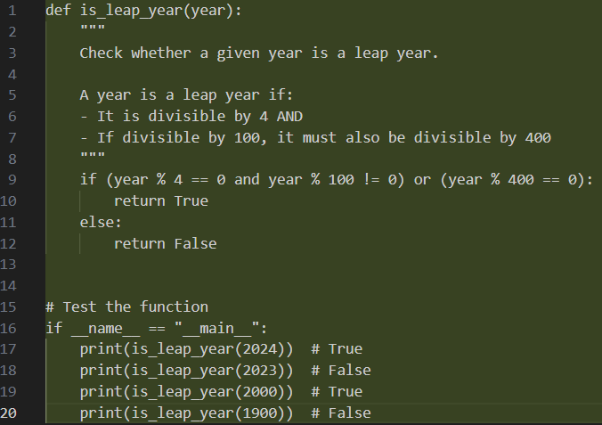
Explanation:
- A year is a leap if:
- It is divisible by 4 and not divisible by 100 , OR
- It is divisible by 400
- The generated python code applies these conditions, checks if the given year is leap year and returns the boolean value.
Output:
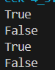
Task 2: One-Shot Prompting – Centimeters to Inches Conversion
Prompt:
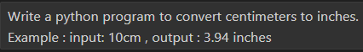
Code:
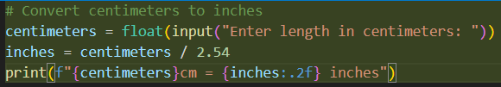
Output:
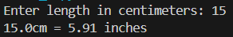
Explanation:
- 1 cm = 2.54 inches
- In the generated code, to get the inches the code divides the cm by 2.54
- One example that is prompted helped AI to calculate it correctly.

Task 3: Few-Shot Prompting – Name Formatting Scenario
Prompt:
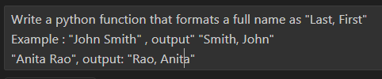
Code:
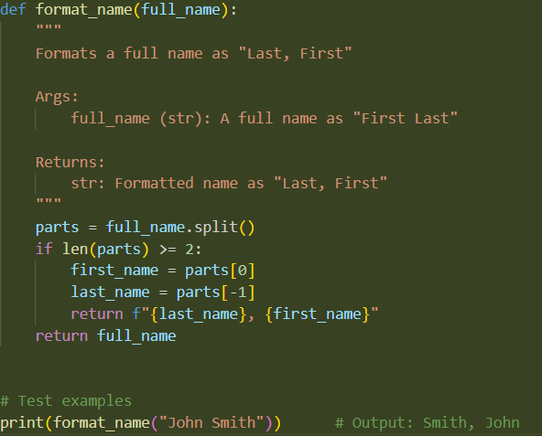
Output:
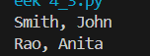
Explanation:
- The given input string is split into two parts, i.e. first and last name.
- If the name contains two or more parts:
- The first element is considered the first name.
- The last element is considered the last name.
- These values are then rearranged and returned in the format “Last, First” using an f-string.
- If the input contains only one word, the function returns the name as it is.

Task 4: Comparative Analysis – Zero-Shot vs Few-Shot Scenario
Zero-shot Prompt:
Code:
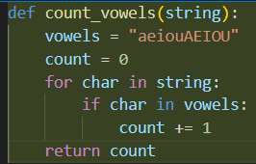
Few-shot prompt:
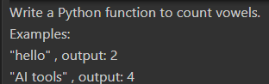
Code:
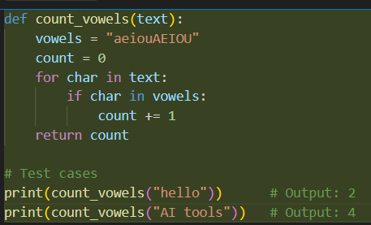
Output:
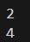
Explanation:
- Few-shot prompt produced more cleaner and optimised code than zero-shot prompt.
- Providing the examples in prompt made AI understand the problem statement better.

Task 5: Few-Shot Prompting – File Handling
Prompt:
Code:
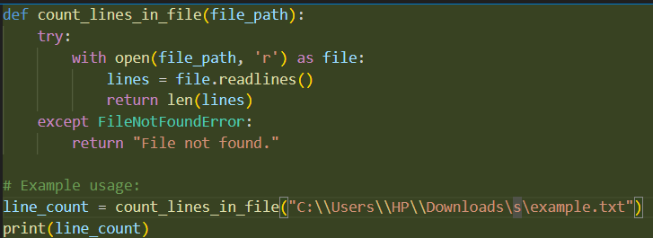
Output:
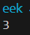
Explanation:
- First, the file is opened in read mode.
- readlines() function reads all the lines into a list.
- len() returns total number of lines.

